Practical 3
Aim
To create an Amazon S3 bucket, upload and download files, configure access permissions, enable bucket versioning, and configure lifecycle rules for automated data management.
Requirements
- An active AWS account
- Internet connection
- Web browser
- AWS Management Console
- A small sample file for testing, such as sample.txt
Introduction
Amazon S3 (Simple Storage Service) is an object storage service provided by AWS. It allows users to store and retrieve files such as documents, images, videos, and backups.
In this practical, an S3 bucket will be created in the Mumbai region. Files will be uploaded and downloaded, access permissions will be configured, versioning will be enabled, and a lifecycle rule will be created to automatically manage stored objects.
Procedure
Step 1: Open Amazon S3
- Sign in to the AWS Management Console using your AWS account.
- In the AWS Console search bar, search for S3.

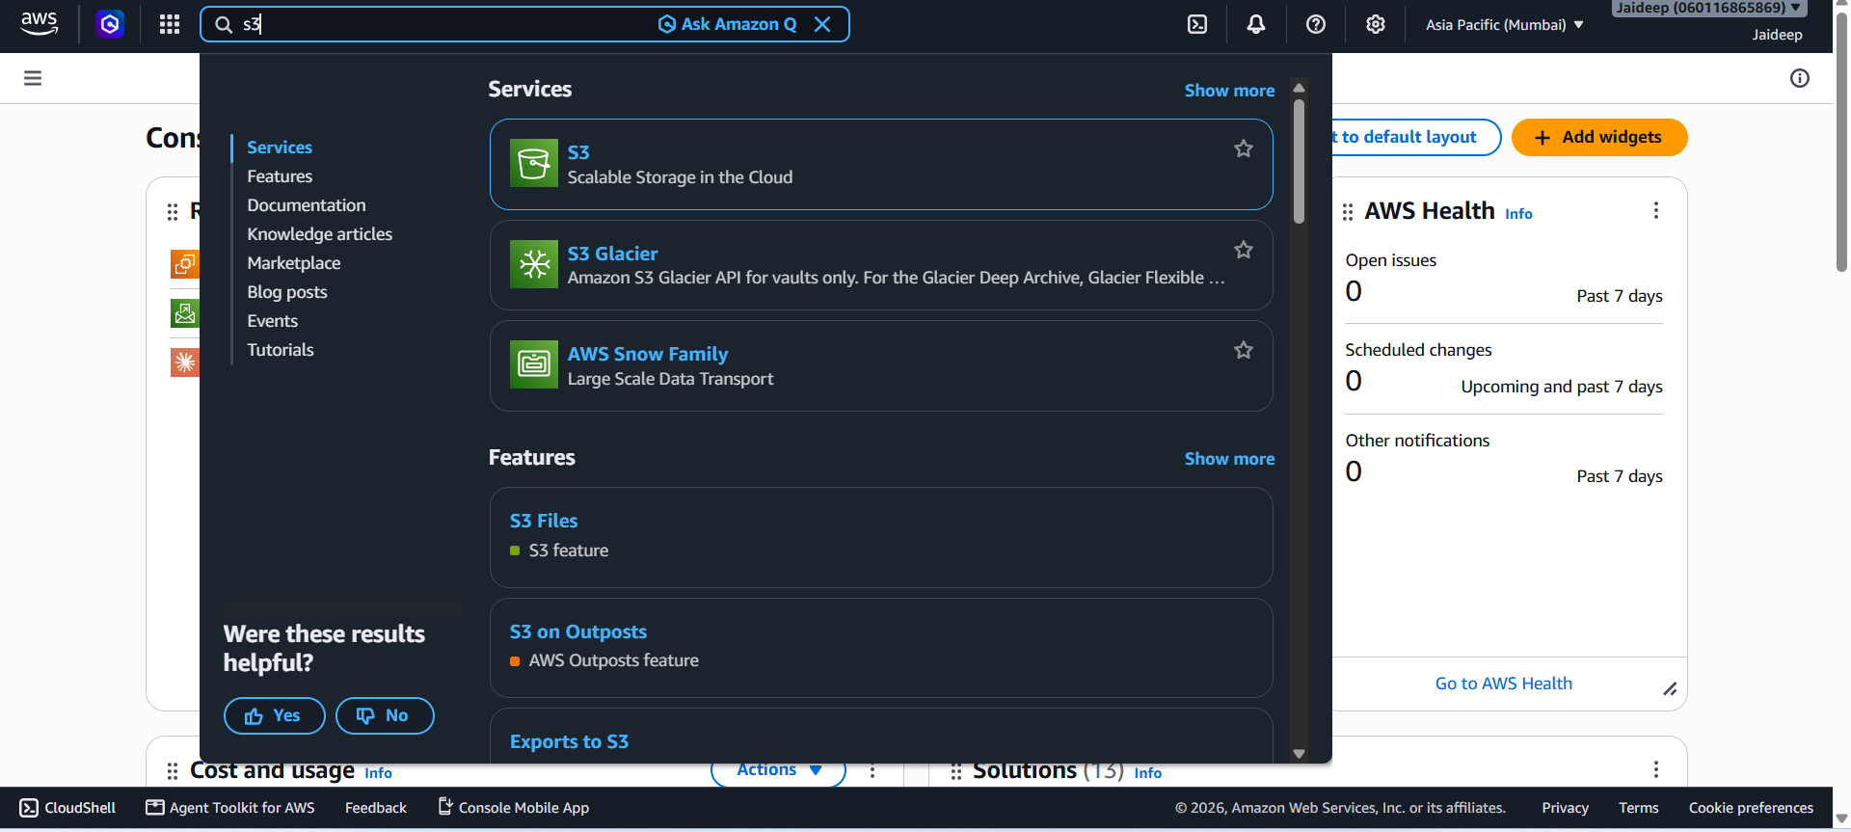
- Open Amazon S3.
- Make sure the selected AWS Region is Asia Pacific (Mumbai) – ap-south-1.
Step 2: Create an S3 Bucket
- In the S3 console, select Create bucket.

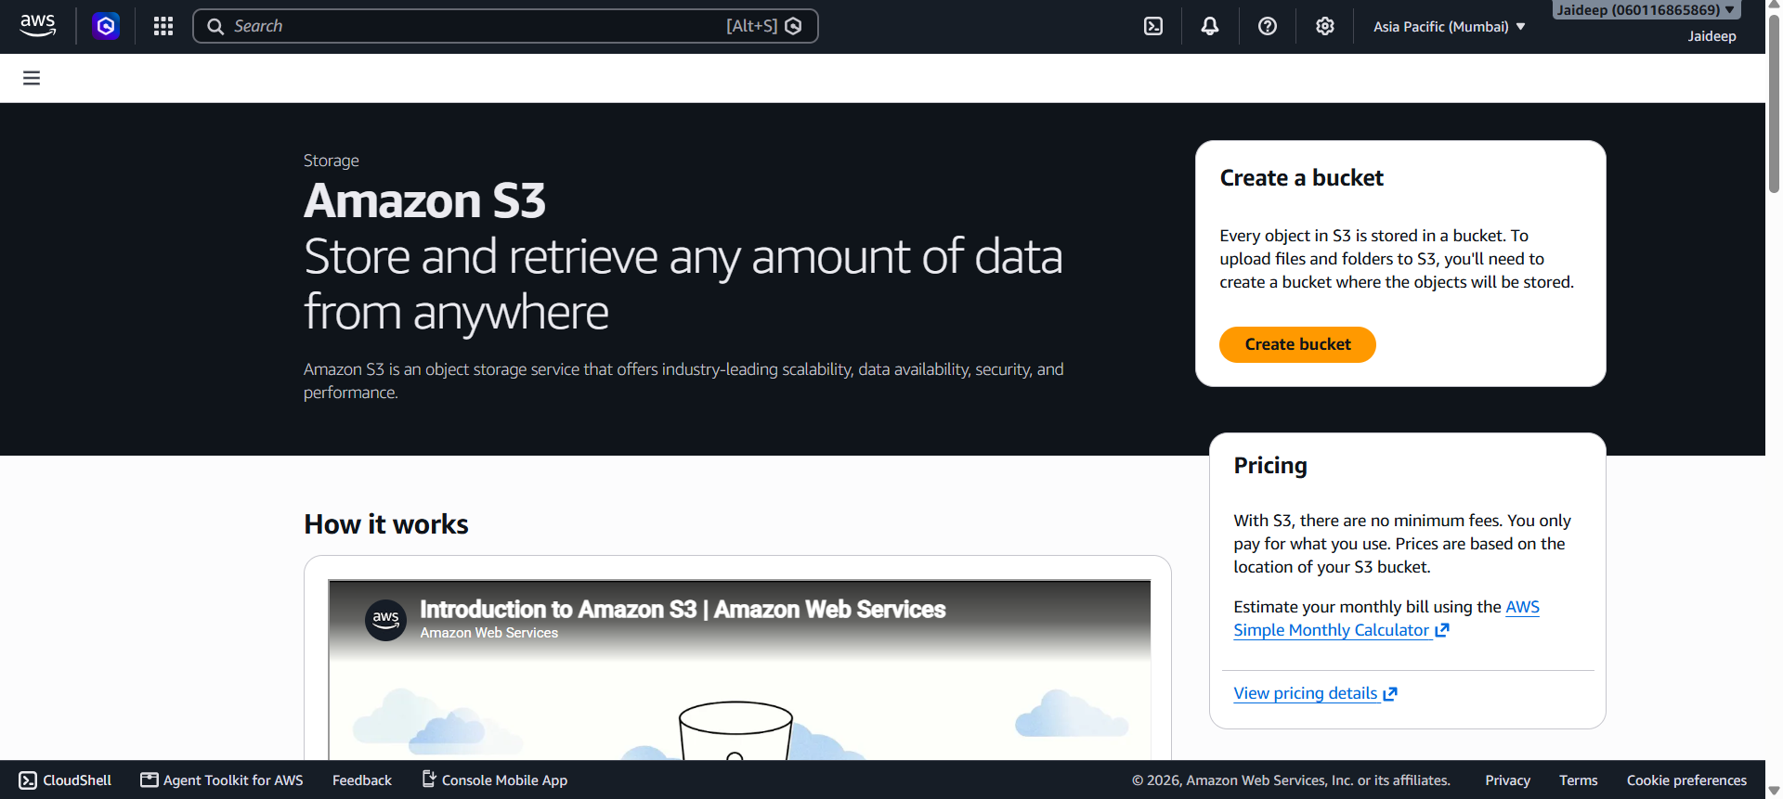
- Enter a globally unique bucket name, for example:
jaideep-s3-practical-2026
If this name is already taken, use another unique name such as:
jaideep-s3-practical-2026-01

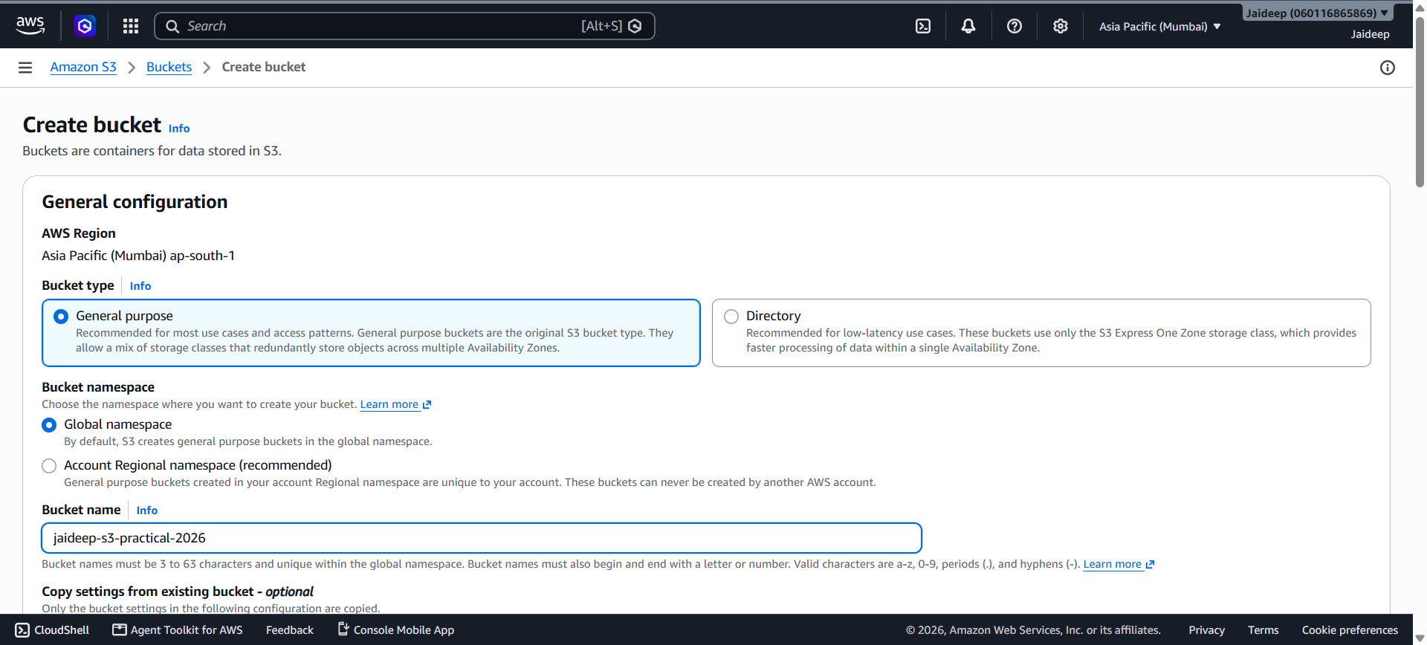
- Keep the default settings for Object Ownership.

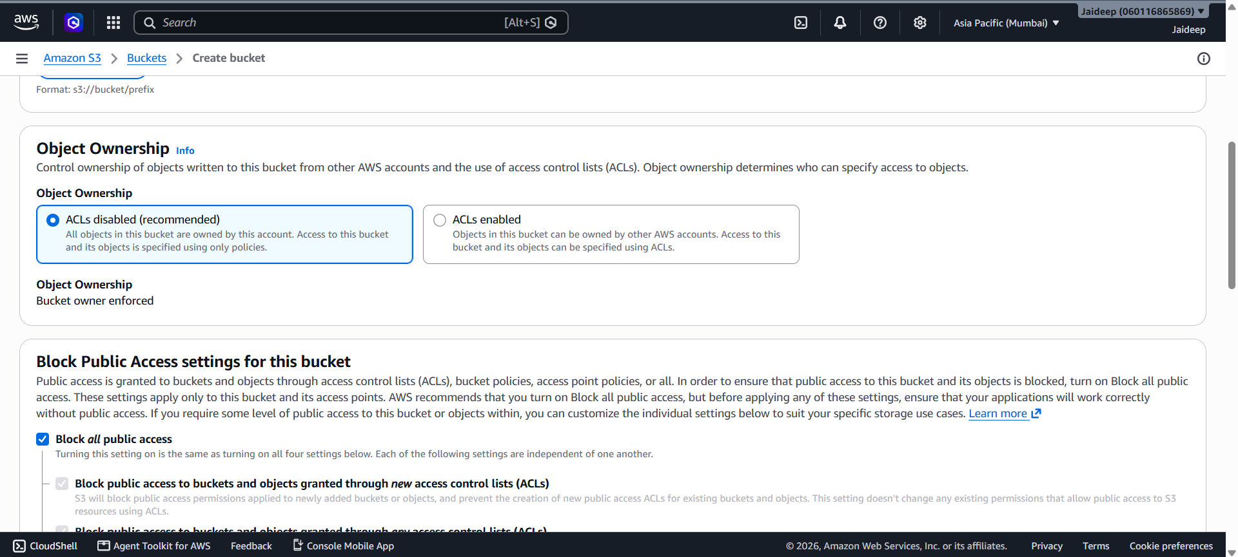
- Keep Block all public access enabled.

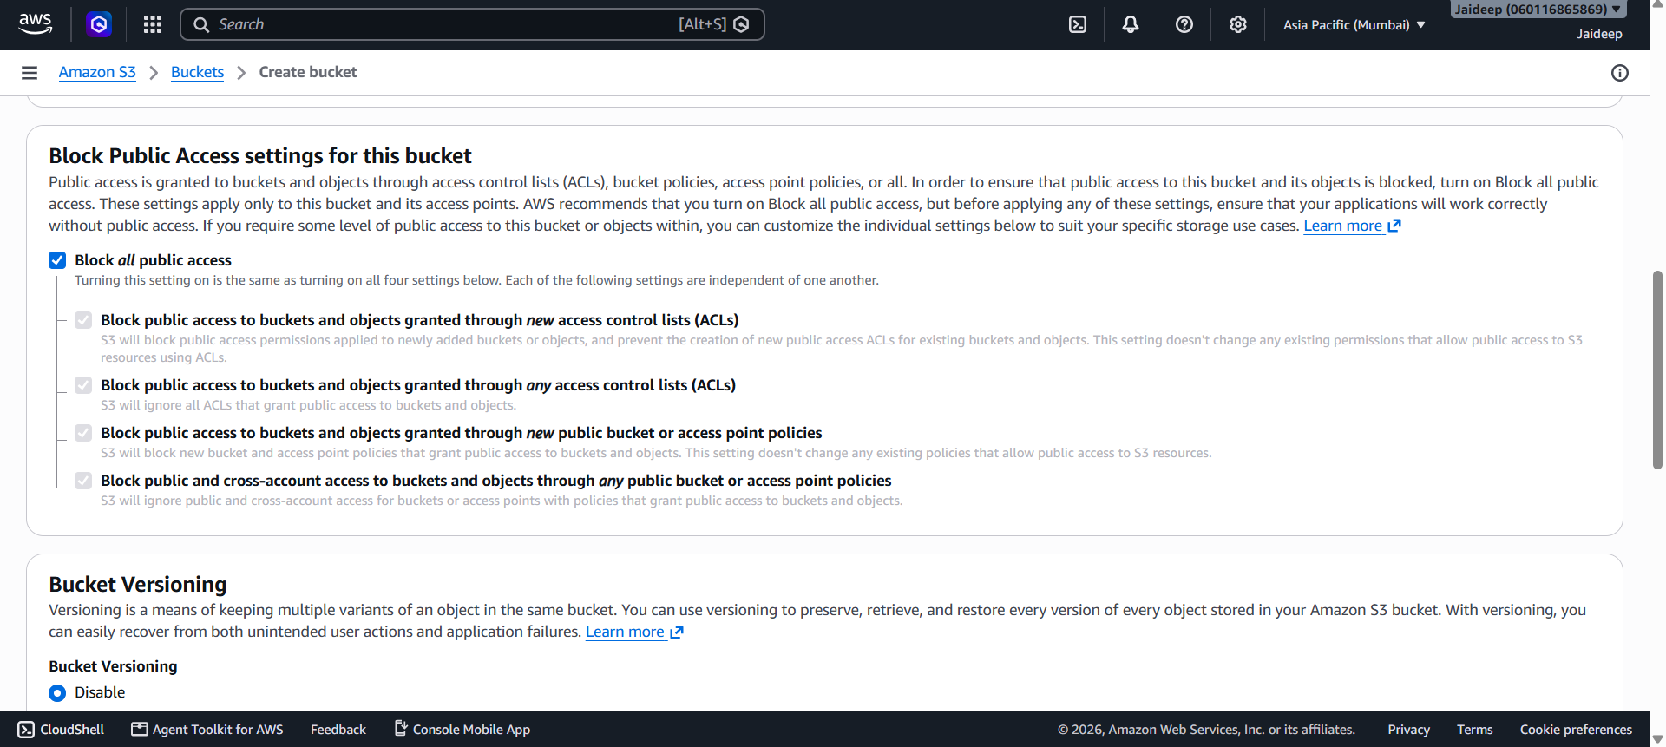
- Keep other settings at their default values.
- Click Create bucket.

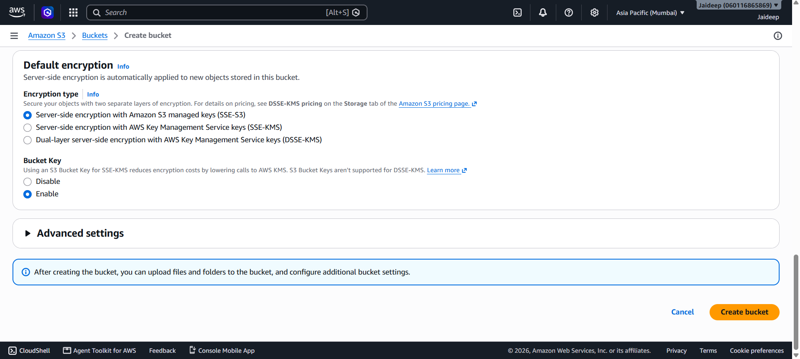
The S3 bucket is now created.

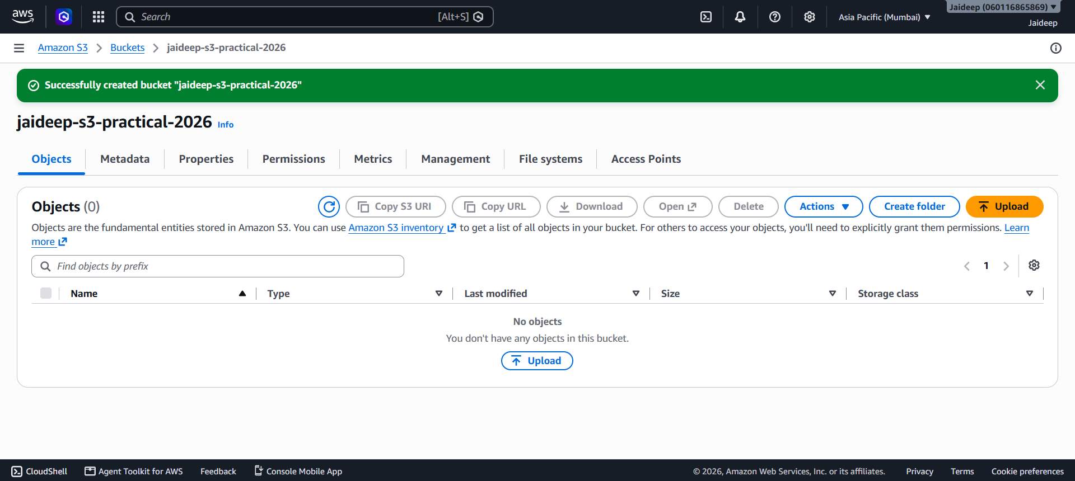
Step 3: Upload a File
- Open the newly created bucket.

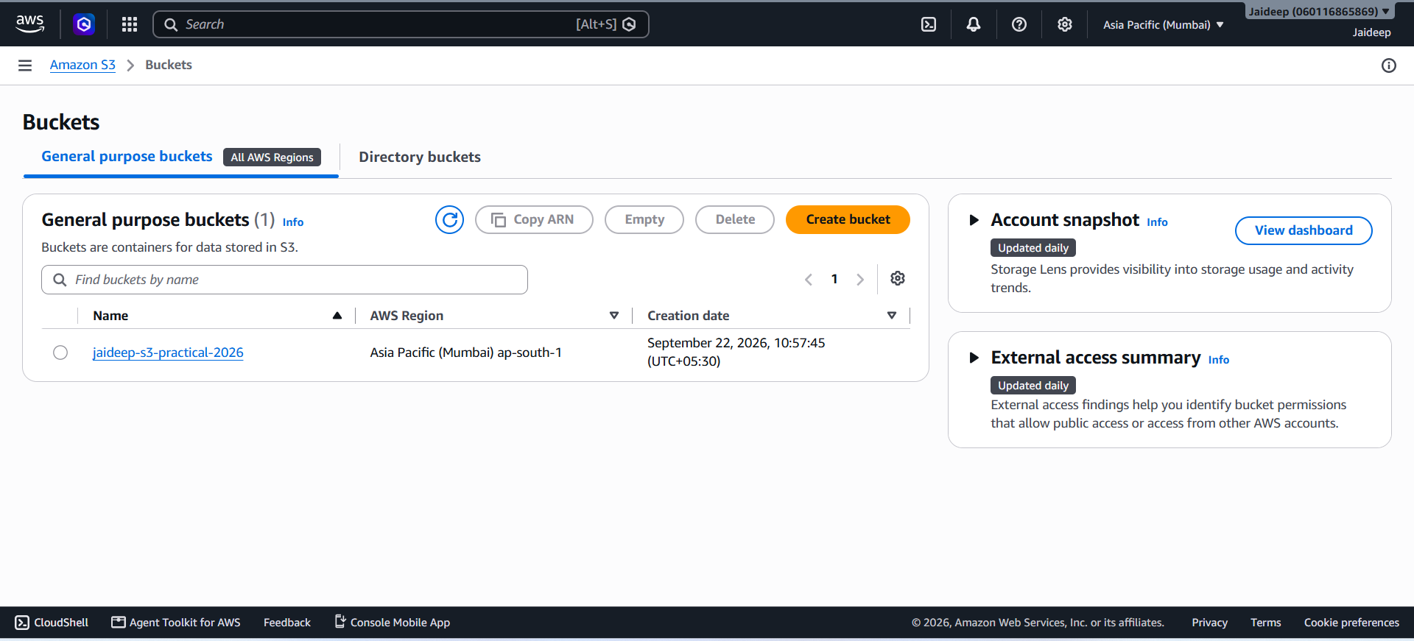
- Click Upload.

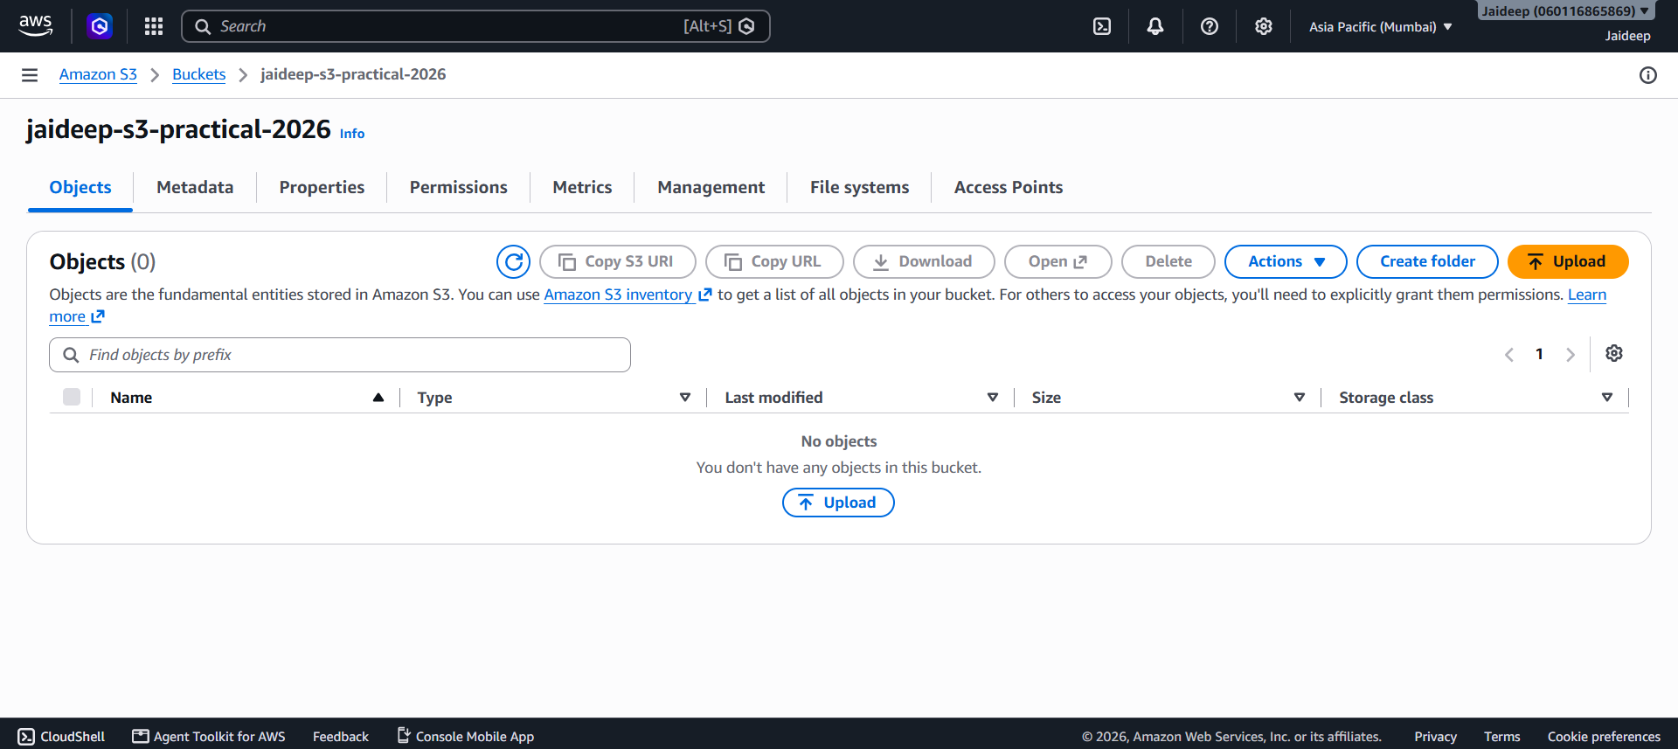
- Select Add files.

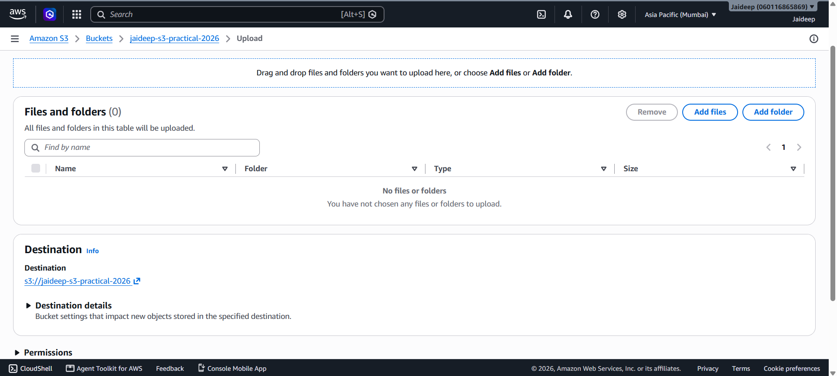
- Choose a small test file, for example:

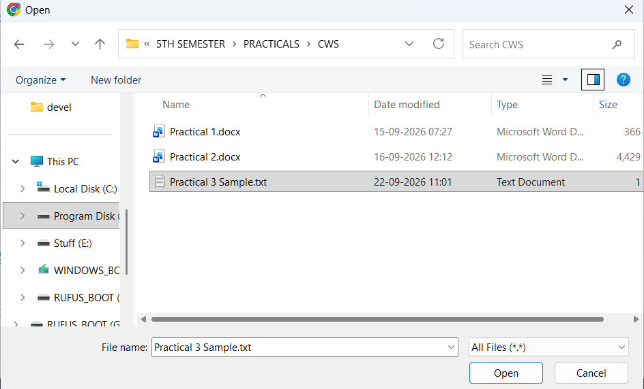
- Click Upload.

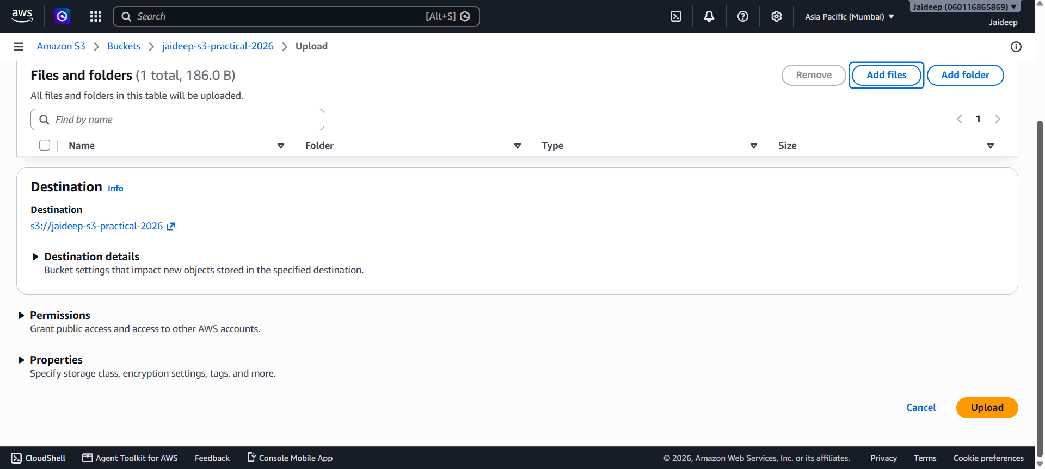
- After the upload is completed, the file will appear in the bucket.

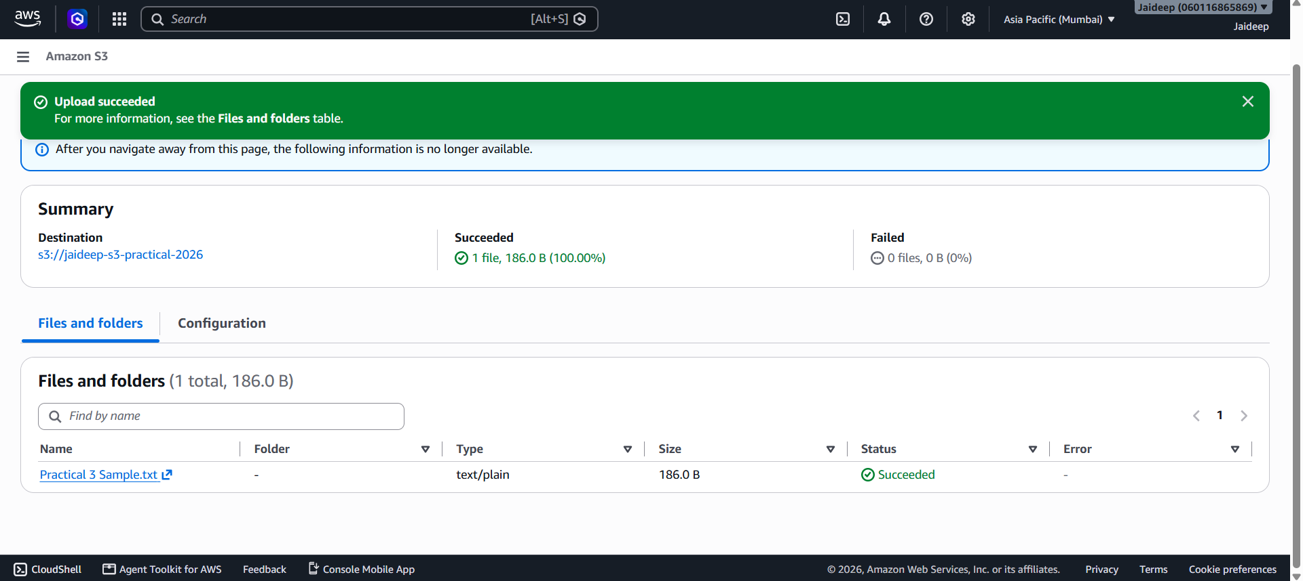
Step 4: Download a File
- Open the bucket.

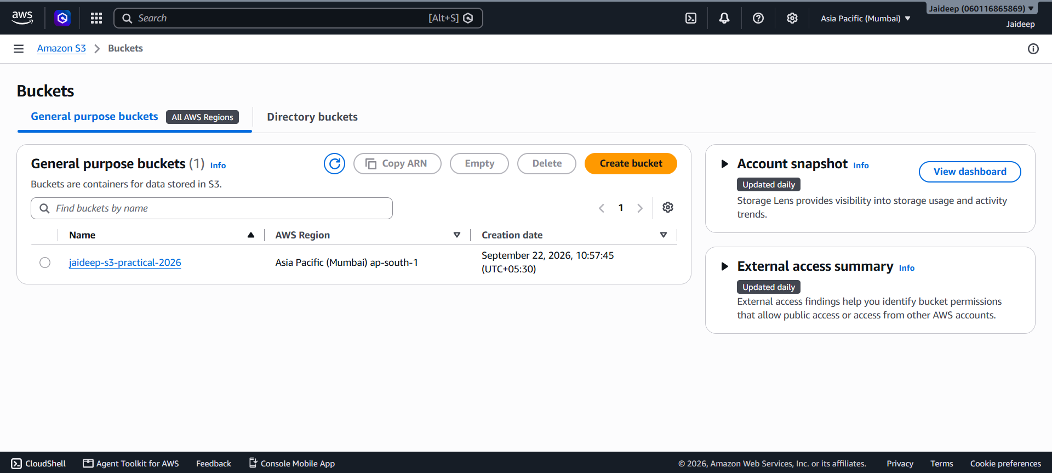
- Select the uploaded file.

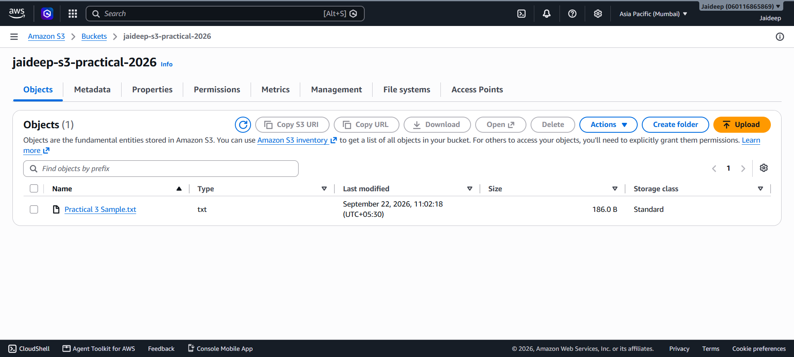
- Click Download.

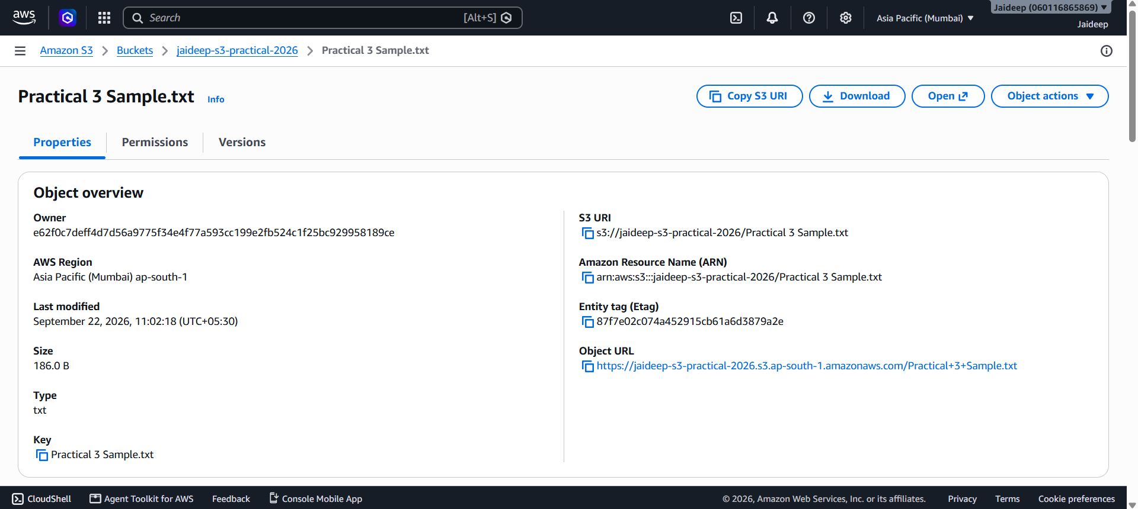
- The file will be downloaded to the local computer.

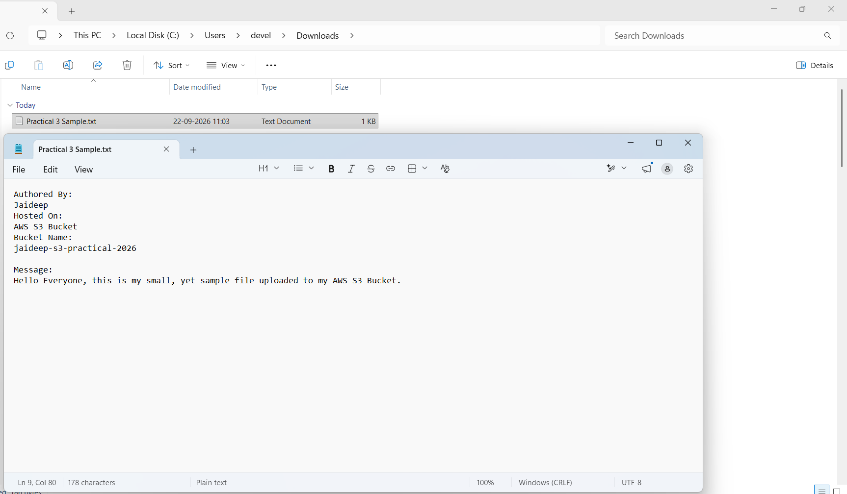
This verifies that the object can be retrieved from the S3 bucket.
Step 5: Configure Access Permissions
For this practical, the bucket should remain private.
- Open the bucket.

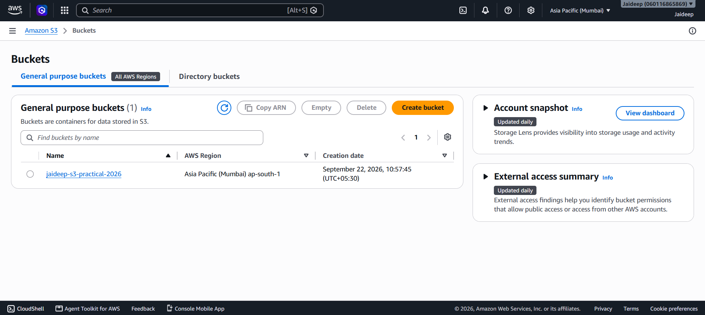
- Go to the Permissions tab.

- Click Edit next to Block public access (bucket settings).

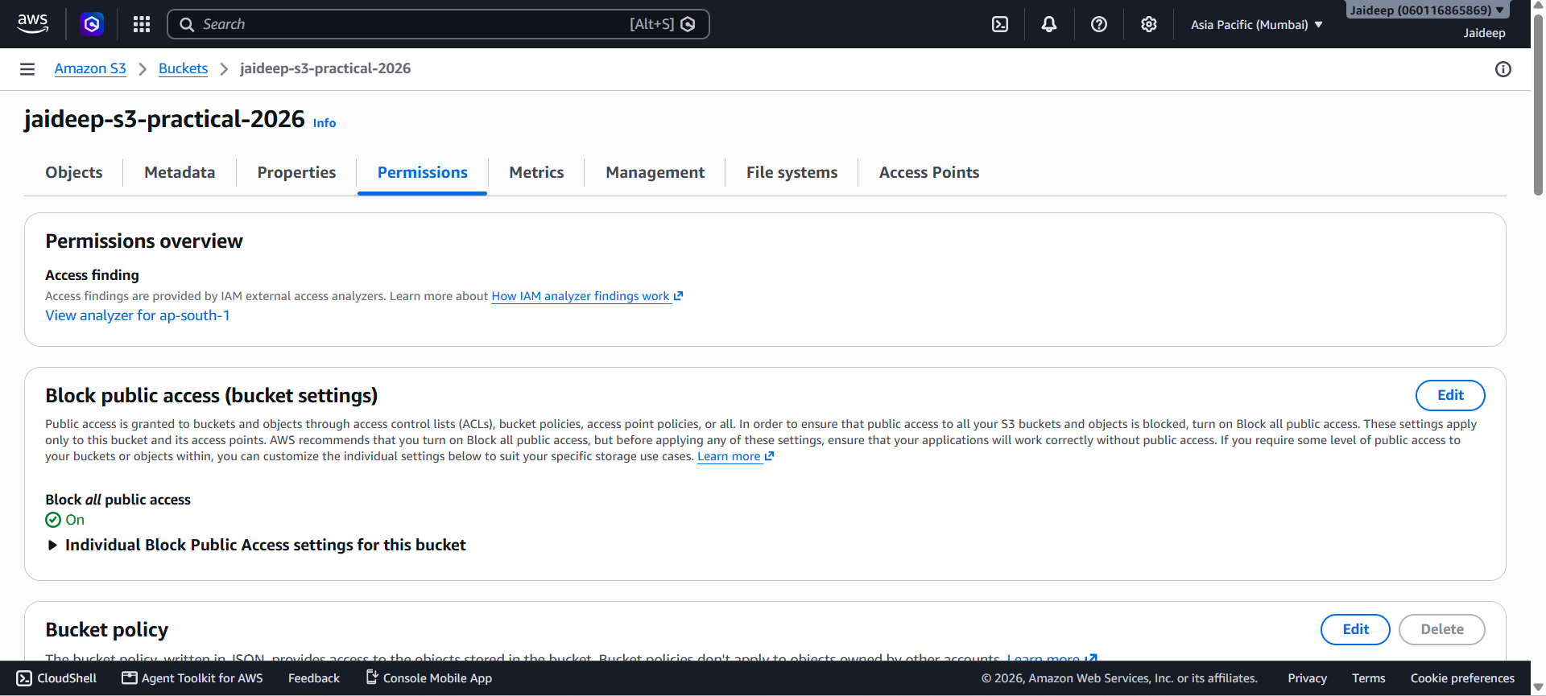
- Keep Block all public access enabled.
- Save Changes.

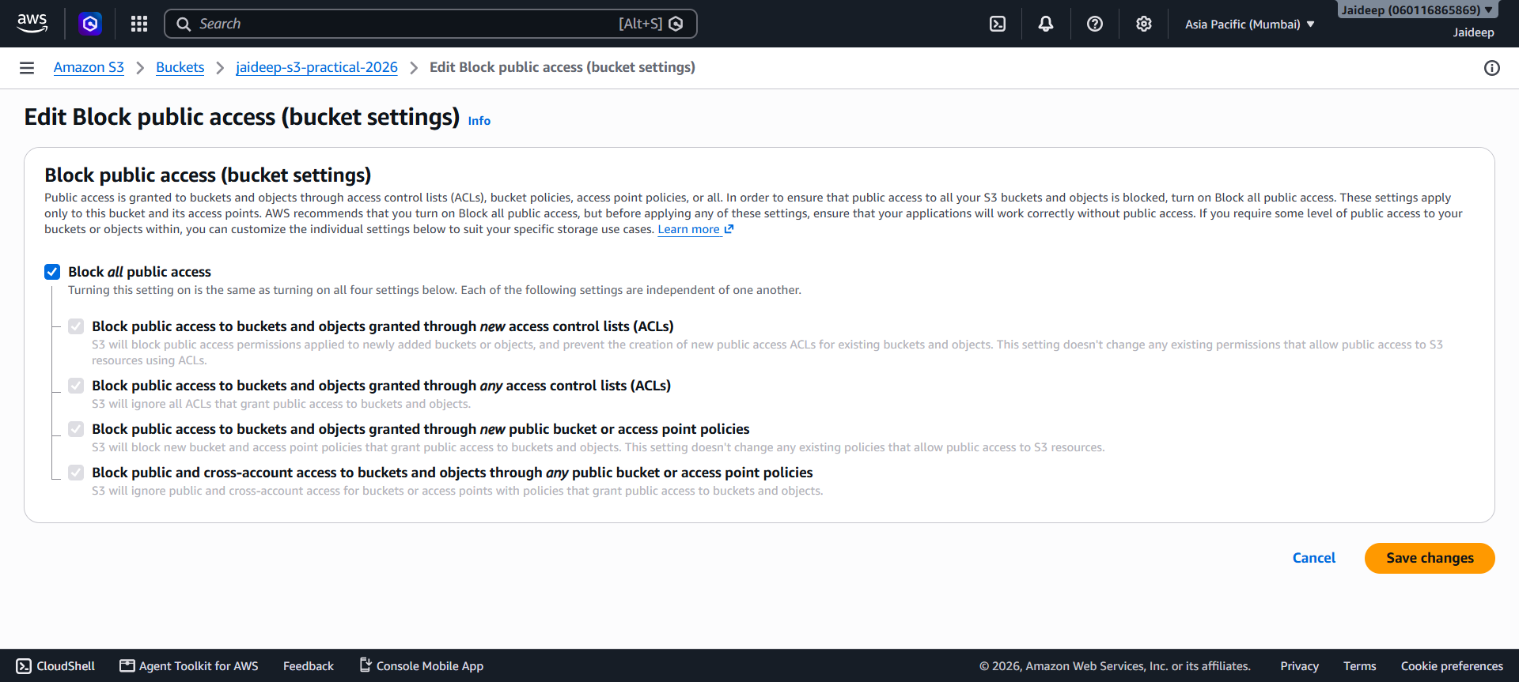
- To confirm the changes, type confirm in the field and click on Confirm.

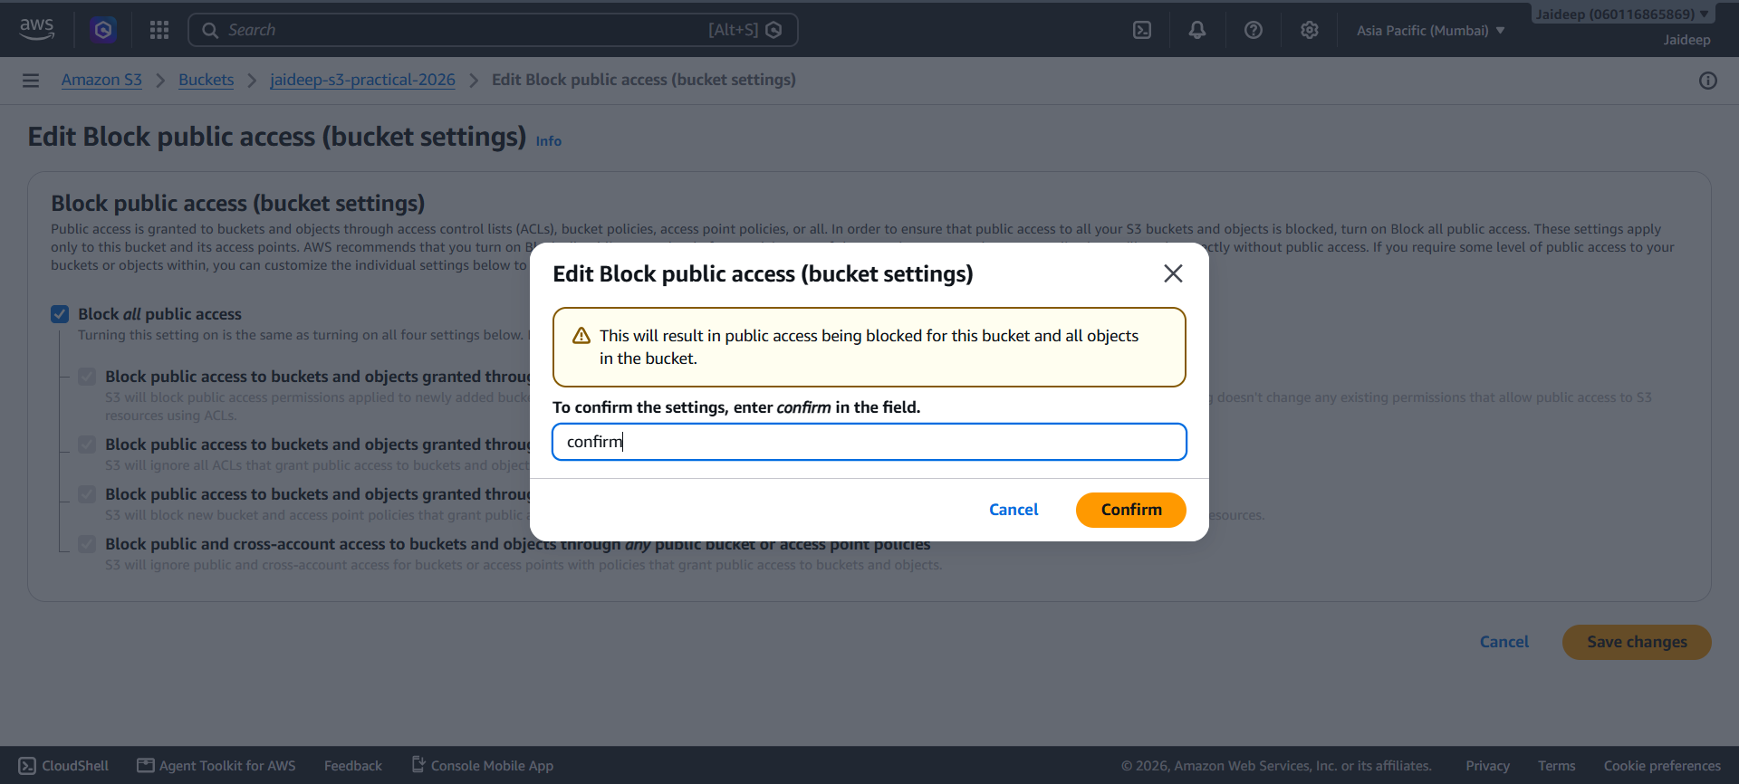
- Review the bucket policy and access control settings.

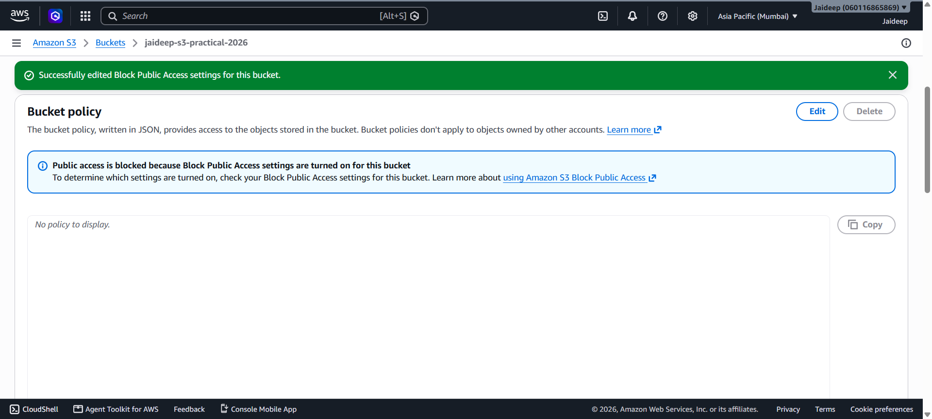
- Do not make the bucket publicly accessible unless specifically required.

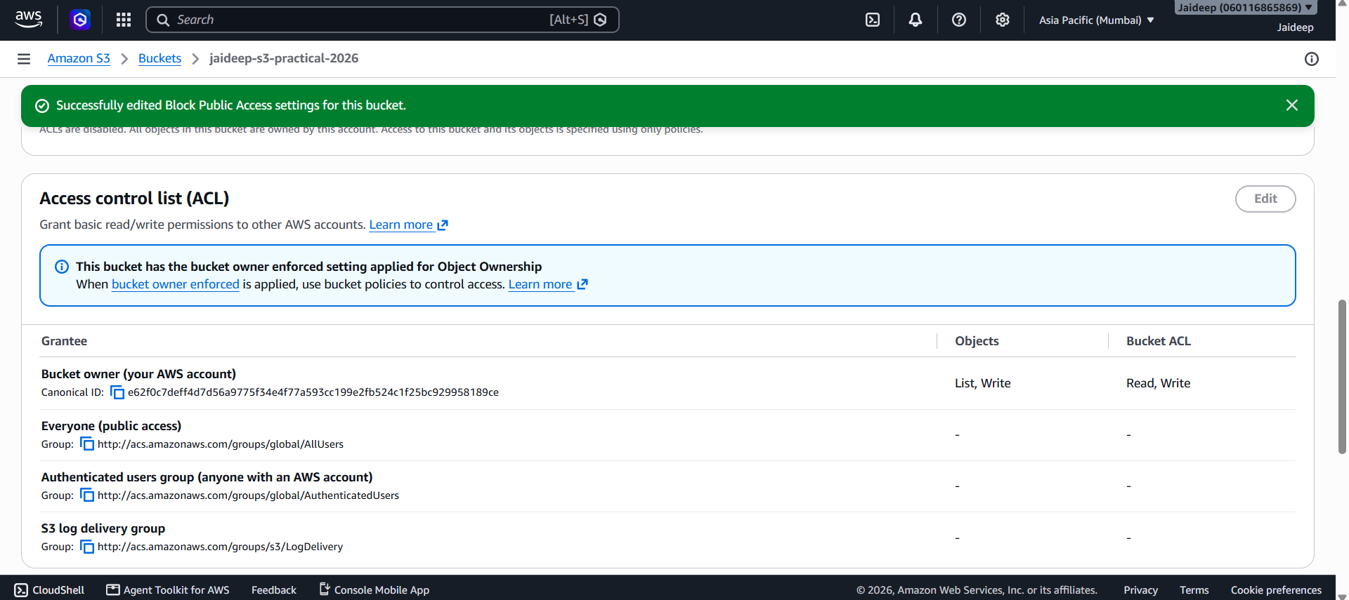
AWS recommends keeping S3 resources private unless public access is intentionally required.
Step 6: Enable Versioning
Versioning allows multiple versions of the same object to be maintained.
- Open the S3 bucket.

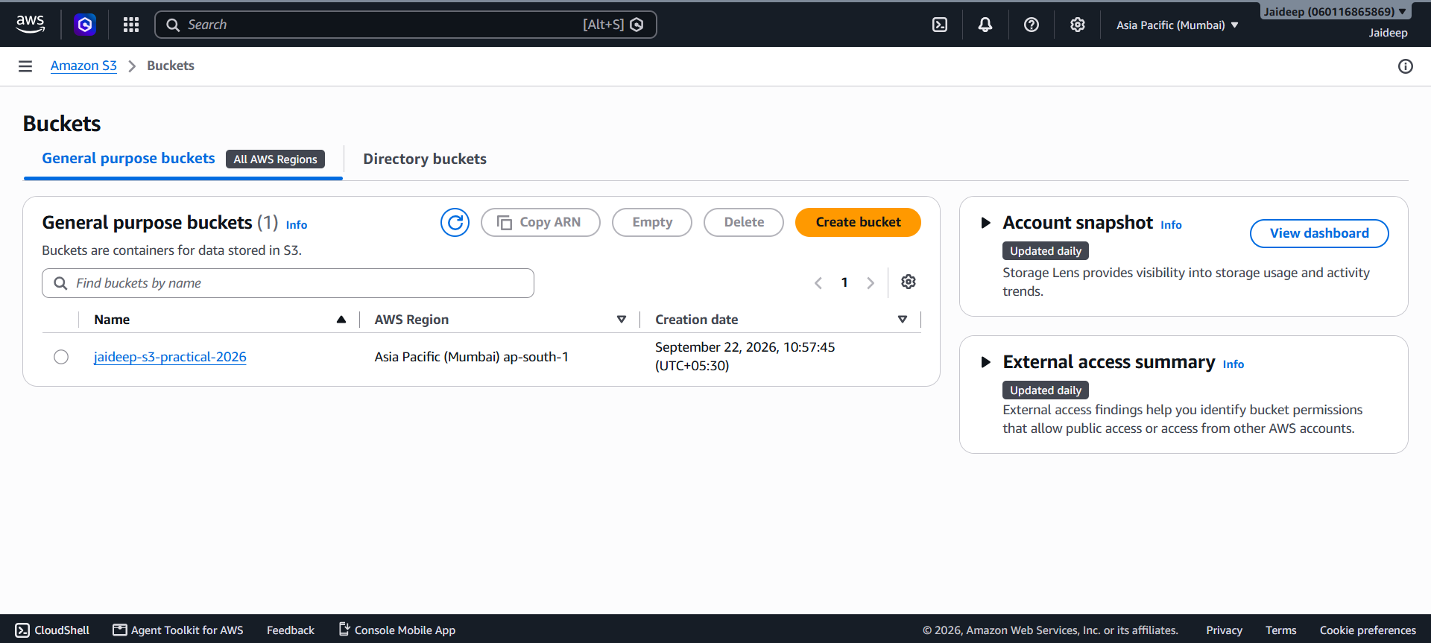
- Select the Properties tab.
- Find Bucket Versioning.

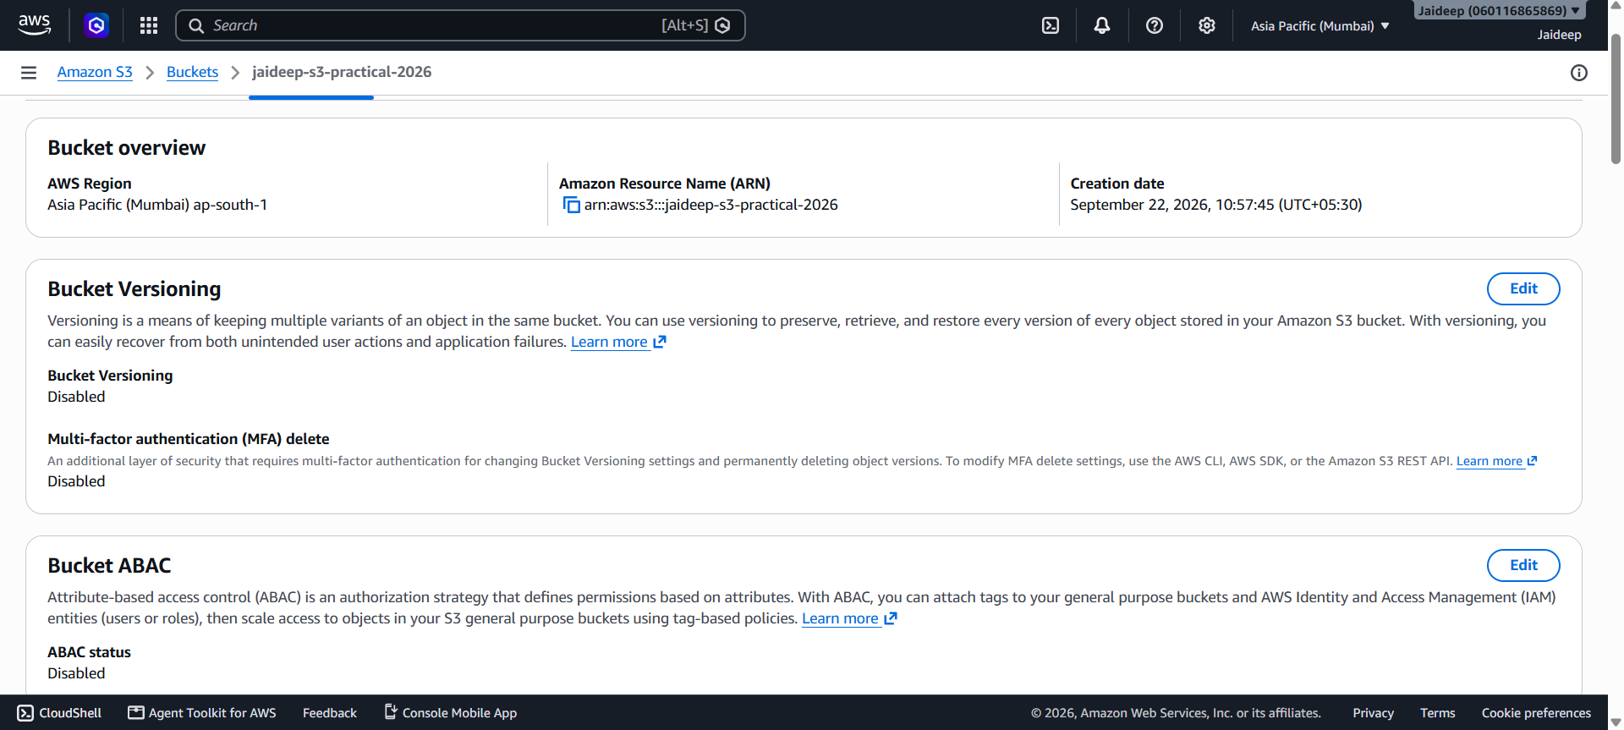
- Click Edit and then toggle the option to Enabled.
- Confirm the change.

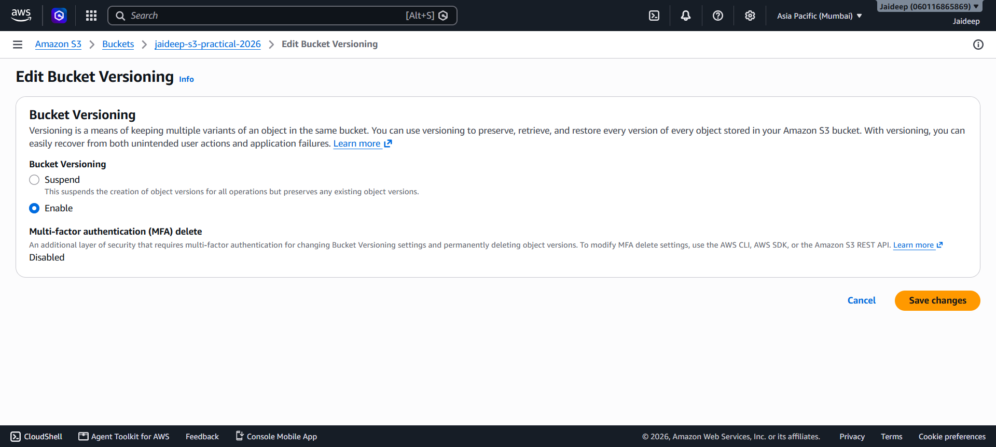

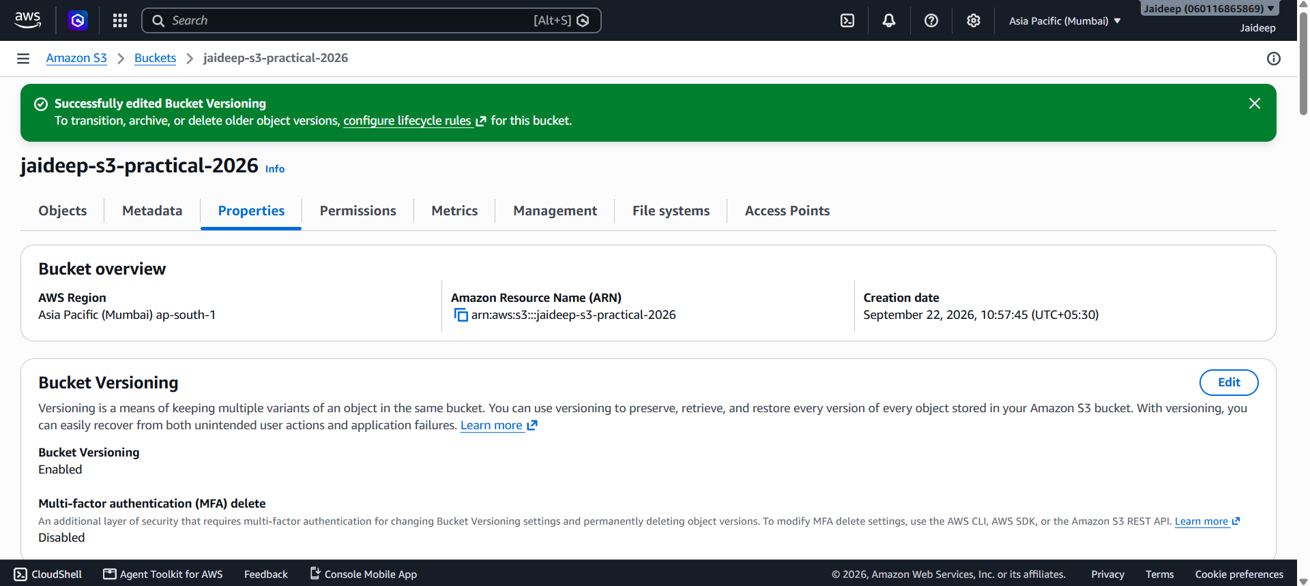
To test versioning:
- Open the bucket.
- Upload another file with the same filename.

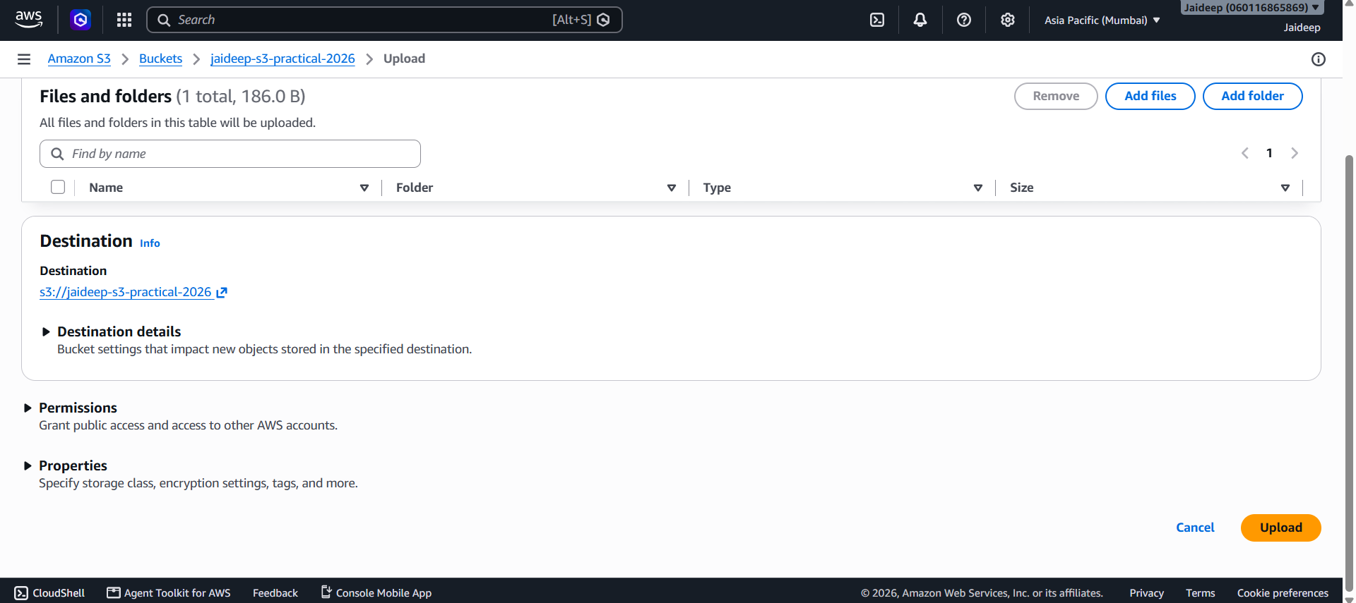
- S3 will maintain different versions of the object.
- The versions can be viewed using the object's version information.

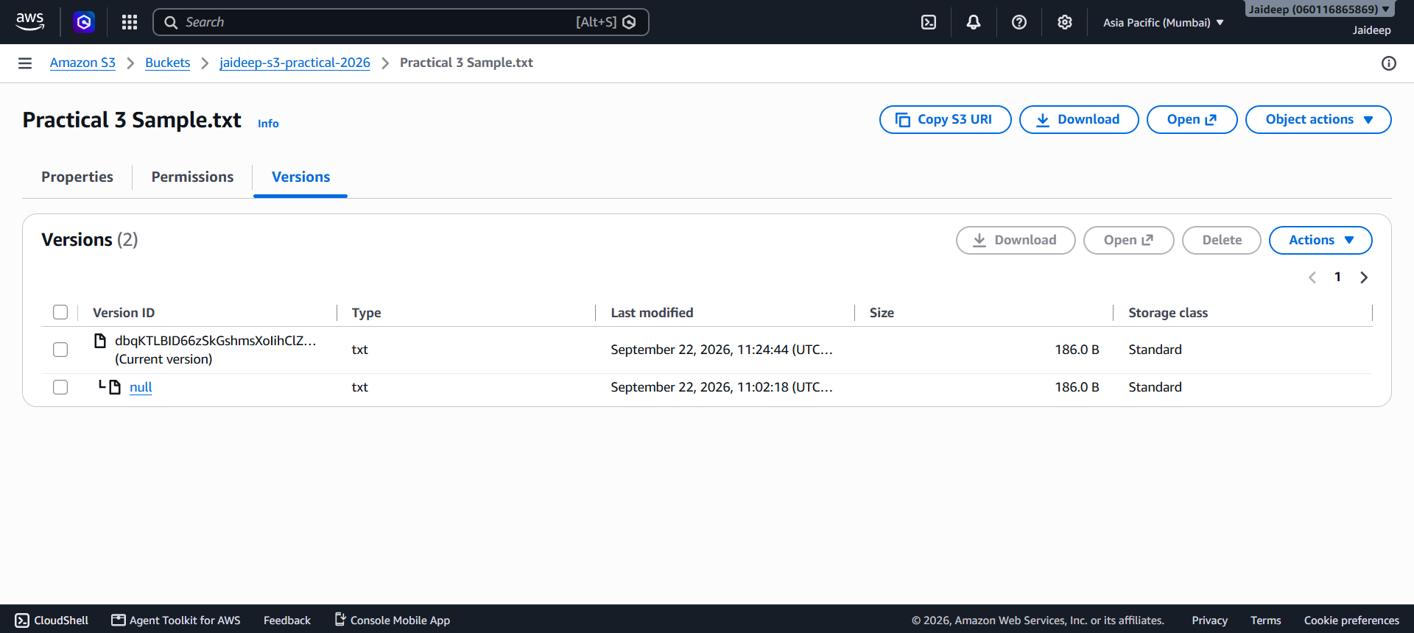
Versioning helps protect objects from accidental overwrites or deletions.
Step 7: Configure a Lifecycle Rule
Lifecycle rules can automatically manage objects as they become older.
- Open the S3 bucket.

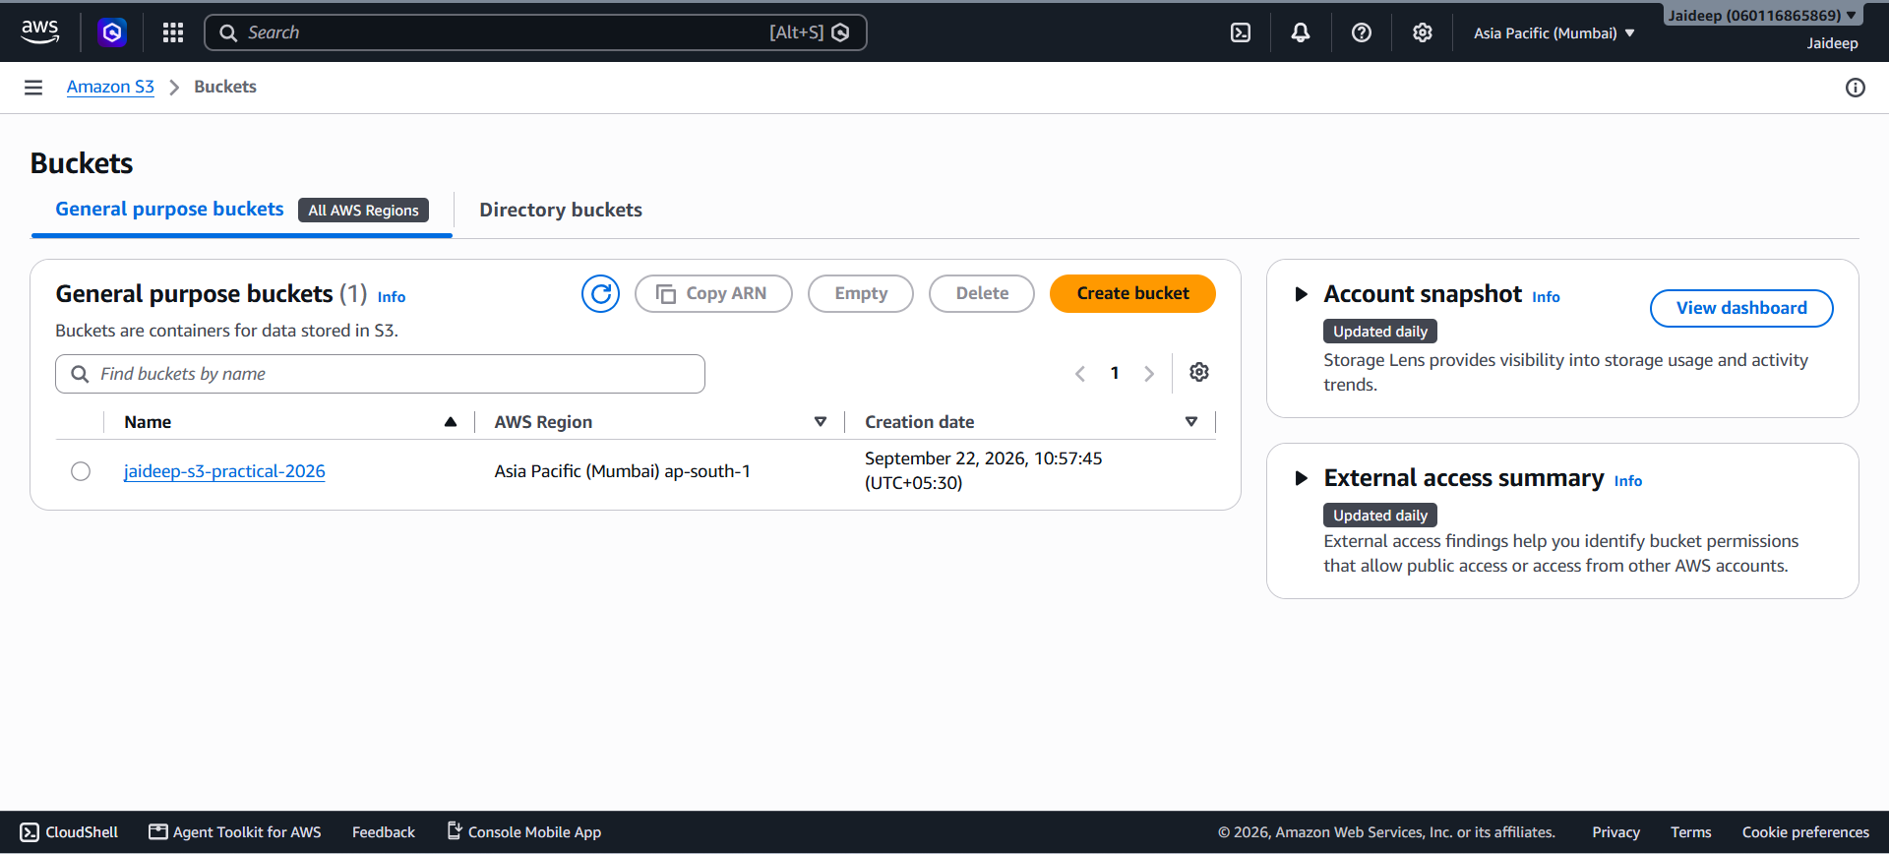
- Go to the Management tab.
- Select Create lifecycle rule.

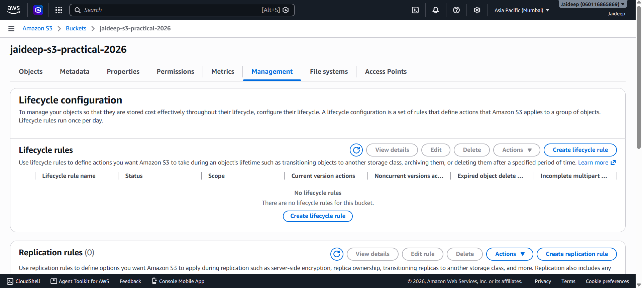
- Enter a rule name, for example:
jaideep-lifecycle-rule
- Apply the rule to all objects in the bucket, if appropriate for this test bucket.

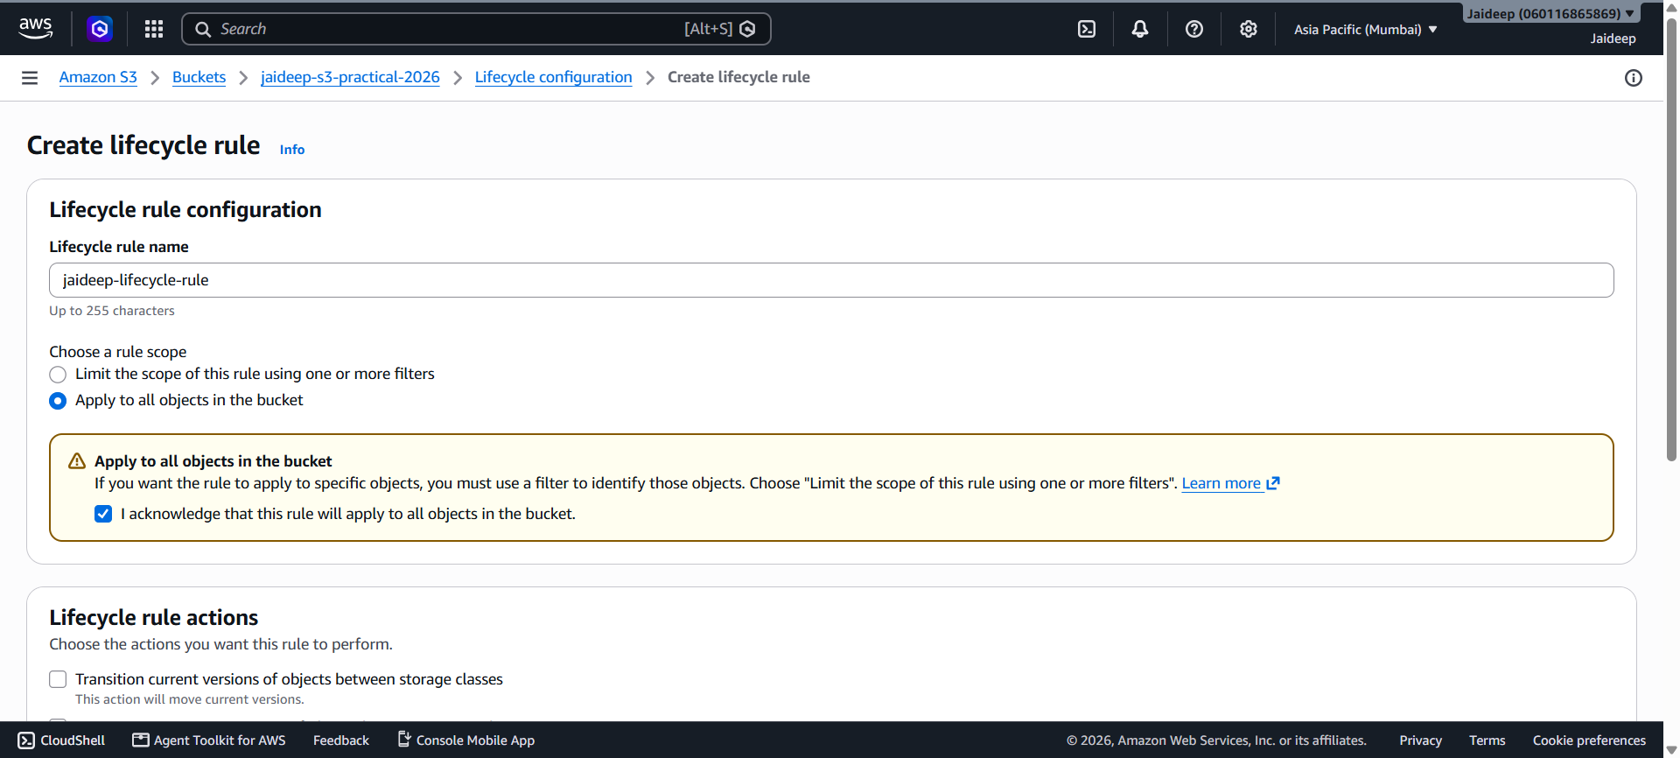
- Configure a lifecycle action.
For a simple practical demonstration, configure the rule to expire current object versions after a suitable number of days, such as 30 days.

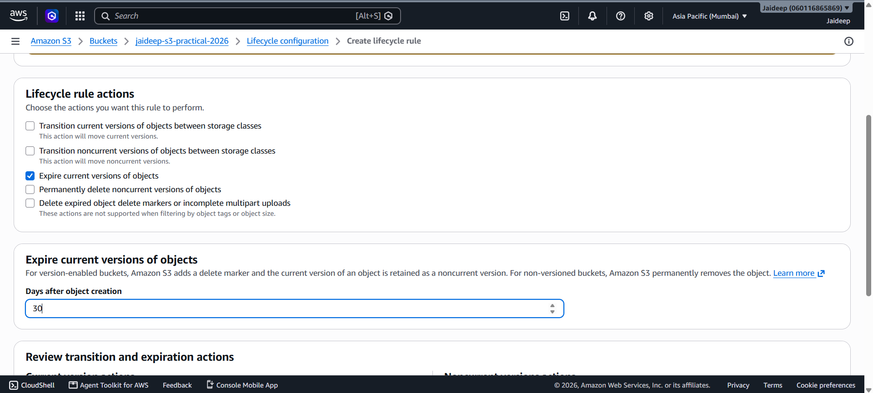
- Review the configuration.
- Click Create rule.

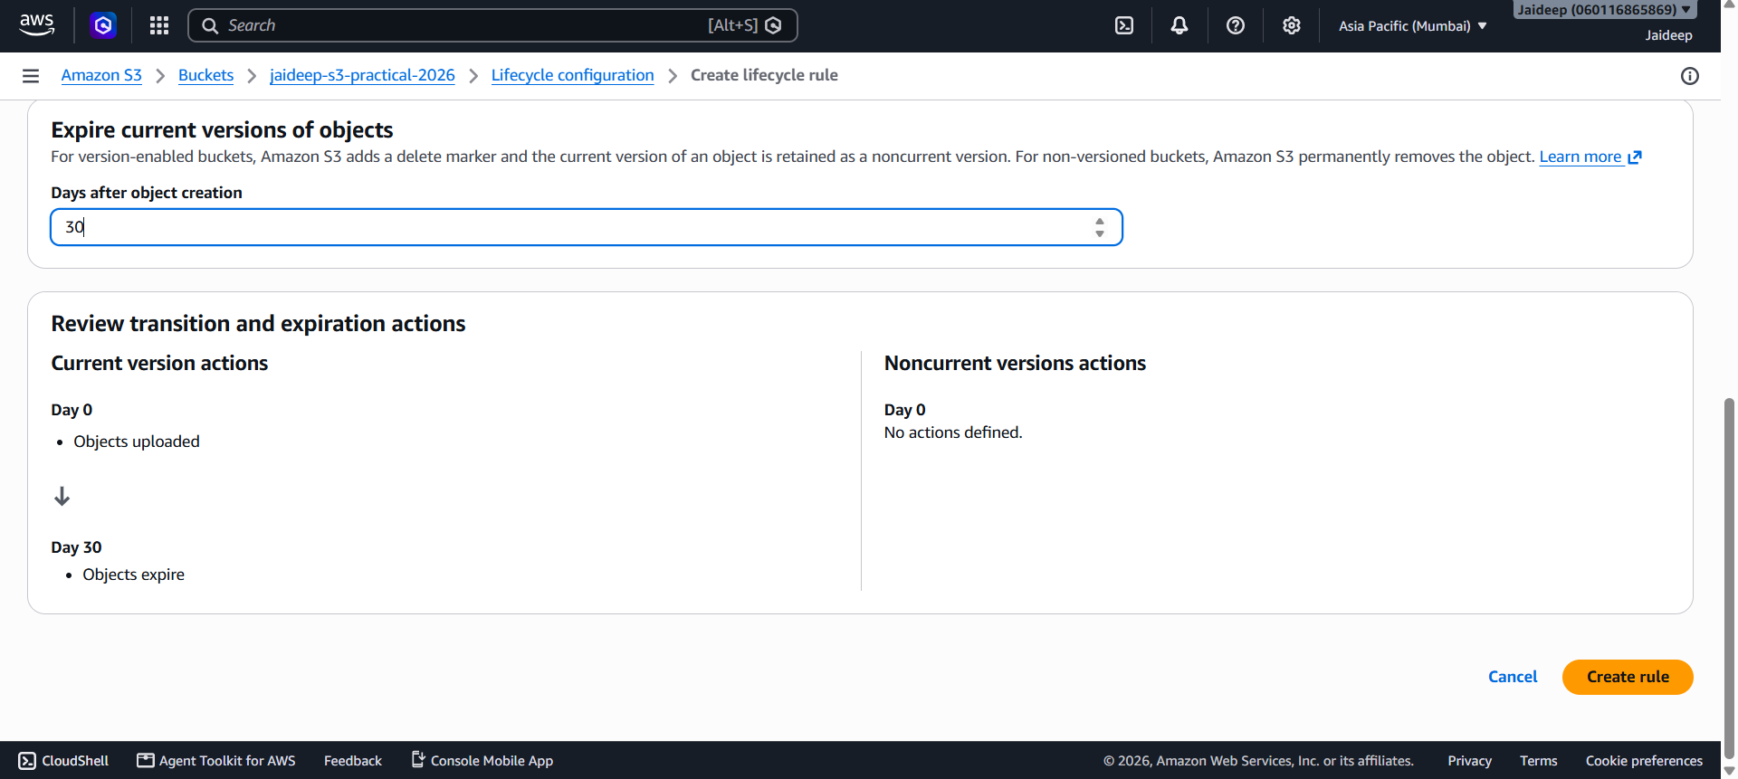
Note: Lifecycle actions are automated and may affect stored data. For a real production bucket, lifecycle periods should be selected according to the organization's data-retention requirements.

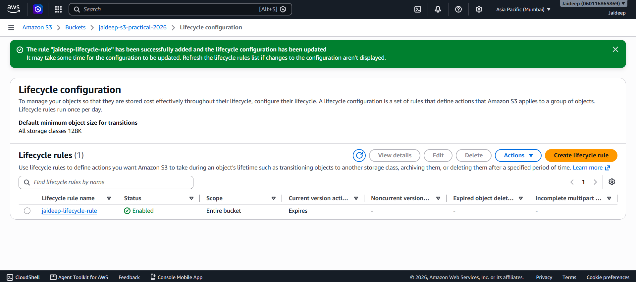
Step 8: Verify the Configuration
The following settings can now be checked:
Feature | Configuration
Bucket | jaideep-s3-practical-2026
Region | Mumbai – ap-south-1
File upload | Practical 3 Sample.txt
File download | Practical 3 Sample.txt
Access | Private / public access blocked
Versioning | Enabled
Lifecycle | Configured
Storage management | Automated through lifecycle rule

Result
An Amazon S3 bucket was successfully created in the Mumbai (ap-south-1) region. A file was uploaded and downloaded successfully. Access permissions were configured to keep the bucket private. Bucket versioning was enabled to maintain multiple versions of objects, and a lifecycle rule was configured for automated object management.

